 

**Assignment submitted for Computer Intelligence Module (CIS6008)**

# Submitted to

**CARDIFF METROPOLITAN UNIVERSITY**

To fulfill partial requirement of BSc (Hons) Software Engineering (Level 6 Top-Up)

Student Name: Patuwatha Withanage Sandun Vidusankha

Student No: 20315393

Institute Branch: ICBT Campus, Galle

## Submission Deadline: 03.03.2025

|  |  |  |  |  |  |  |  |  |  |
| --- | --- | --- | --- | --- | --- | --- | --- | --- | --- |
| **Student Details ( Student should fill the content)** | | | | | | | | | |
| Name | | |  | | | | | | |
| Student ID | | |  | | | | | | |
| **Scheduled unit details** | | | | | | | | | |
| Unit code | | |  | | | | | | |
| Unit title | | |  | | | | | | |
| Unit enrolment details | | | Year | | 3 | | | | |
| Study period | |  | | | | |
| Lecturer | | |  | | | | | | |
| Mode of delivery | | | Full Time | | | | | | |
| **Assignment Details** | | | | | | | | | |
| Nature of the Assessment | | |  | | | | | | |
| Topic of the Case Study | | |  | | | | | | |
| Learning Outcomes covered | | | L01, L02, LO3 | | | | | | |
| Word count | | |  | | | | | | |
| Due date / Time | | |  | | | | | | |
| Extension granted? | | | Yes | No | Extension Date | | |  | |
| Is this a resubmission? | | | Yes | No | Resubmission Date | | |  | |
| **Declaration** | | | | | | | | | |
| I certify that the attached material is my original work. No other person’s work or ideas have been used without acknowledgement. Except where I have clearly stated that I have used some of this material elsewhere, I have not presented it for examination / assessment in any other course or unit at this or any other institution | | | | | | | | | |
| Name/Signature | | |  | | | Date | |  | |
| **Submission** | | | | | | | | | |
| Return to: | | |  | | | | | | |
| **Result** | | | | | | | | | |
| Marks by 1st Assessor |  | Signature of the 1st Assessor | | | | |  | | **Agreed Mark** |
| Marks by2nd Assessor |  | Signature of the 2nd Assessor | | | | |  | |  |

|  |  |  |  |
| --- | --- | --- | --- |
| **Comments on the Agreed Mark.** | | | |
| **For Office use only (hard copy assignments)** | | | |
| Receipt date |  | Received by |  |

|  |  |  |
| --- | --- | --- |
| **STUDENT NAME:**  W A Chapa Chandi | | **STUDENT NUMBER:** 20284618 |
| **Module Number & Title**: CIS6005 | | **Semester: 02** |
| **Assignment Type & Title:** | | |
| **For student use: *Critical feedback on the individual progression towards achieving the assignment outcomes*** | | |
|  | | |
| **For the Assessors’ feedback**  **Indicate the Task number strength and Weaknesses and the marks for each task** | | |
| **Task No/Quest ion No**  **Task 01**  **Task 02**  **Task 03**  **Task 04**  **Task 05**  **Task 06** | **Strengths**  Proper structure | |

|  |  |  |  |  |
| --- | --- | --- | --- | --- |
| **Task No / Question No**  **Task 01**  **Task 02**  **Task 03**  **Task 04**  **Task 05**  **Task 06** | **Weaknesses** | | | |
| **Areas for future improvement** | | | | |
|  | | | | |
| **Marks** | | | | |
| **Task**  **/Question No** | | **Allocated Marks** | **Awarded Marks** | **Remarks** |
|  | |  |  |  |
|  | |  |  |  |
|  | |  |  |  |
|  | |  |  |  |
|  | |  |  |  |
| **Total Marks** | |  |  |  |
| **Name and the Signature of the Assessor** | | |  | |
| **Date** | | |  | |

# Acknowledgment

I am deeply grateful to all those who have contributed to the successful completion of this research paper. I am profoundly appreciative of the support I have received, as this endeavour has been an invaluable learning experience.   
  
I would like to commence by expressing my sincere appreciation to my preceptor, Dr. Manisha Kaldera, for his unwavering support and guidance. His insights and expertise were essential in overcoming the challenges I faced throughout this process. It has been an immeasurable privilege to study this subject under his mentorship, and this endeavour would not have been as successful without his exceptional assistance.   
  
In addition, I am grateful to my parents for their unwavering support and encouragement, as well as to all those who provided guidance and assistance throughout the process. Their contributions were essential to the success of this endeavour. I would also like to extend my appreciation to the lecturers and staff who provided assistance with a diverse array of duties and activities that were associated with this endeavour.

# Executive Summary

This work uses artificial intelligence (AI) to anticipate rucksack pricing by investigating many product attributes. Important elements in the dataset are brand, material, size, weight capacity, and style; all of these contribute to define the final pricing rather considerably. The major objective is to create a machine learning model by means of research of these features capable of reasonably projecting rucksack pricing.   
  
To find trends and connections in the dataset, the approach asks exploratory investigation, feature engineering, and data preparation. Using several machine learning techniques like ensemble approaches and regression-based models helps one to find the optimal consistent forecasting strategy. Measures like Root Mean Squared Error (RMSE) and Mean Absolute Error (MAE) help to evaluate the model's performance so guaranteeing accuracy and efficiency.   
  
This paper emphasises the use of artificial intelligence (AI) in the pricing evaluation process, therefore offering e-commerce platforms, stores, customers, and companies with smart analysis. Emphasising the need of machine learning in the projections for research and consumer pricing, the last model is meant to provide consistent pricing estimates.

Table of Contents

Submitted to 1

Submission Deadline: 03.03.2025 1

Acknowledgment 6

Executive Summary 7

List of Figures 9

Section 01 10

1.Introduction 10

1.1 Background 10

1.2 Overall Description 11

1.3 More on Deep Learning 12

Chapter 02 13

2. Literature Review 13

2.1 Introduction 13

2.2 Price Predicitoin in Retails and E-Commence 13

2.3 Feature Importance in Product Pricing. 13

2.4 Machine Learning Methods for Price Prediction 14

2.5 Challenges in Price Prediction 14

2.6 Applications and Implications 15

2.7 Conclusion 15

3 Exploratory data analysis (EDA) 16

4. System Architecture and How It Differs from Others 26

4.1 Architecture of the current implementation 26

4.2 Components of the current implementation in architecture 27

4.2.1 Data Collection 27

4.2.2 Data Cleaning and Transformation 27

4.2.3 Statical Data Analysis 27

4.2.4 Model Training 27

4.2.5 Performance Evaluation 28

4.2.6 Model Integration (API Development) 28

4.2.7 Application Deployment (Web/Mobile) 28

4.3 How This Architecture Differs from Others 28

4.4 Conclusion 29

6. Final Model Evaluation and Project Success 30

6.1 Project Narrative and Key Objectives 30

6.2 Model Development Workflow 30

6.3 Performance Metrics and Model Evaluation 31

6.4 Key Challengers, Strategies and Derived Solutions 31

6.5 Practical Application and Deployment Strategy 32

6.6 Business Impact and Industry Relevance 33

6.7 Potential Enhancements and Future Development 33

6.8 Conclusion and Overall Project Success 34

Reference 35

# List of Figures

**Figure 1 Feature Correlation Heatmap** 16

**Figure 2 Price Distribution Histogram** 17

**Figure 3 Boxplot of Price by Brand** 18

**Figure 4 Boxplot of Price by Material** 19

**Figure 5 Boxplot of Price by Size** 20

**Figure 6 Boxplot of Price by Style** 21

**Figure 7 Boxplot of Price by Color** 22

**Figure 8 Boxplot of Price by Laptop Compartment** 23

**Figure 9 Boxplot of Price by Waterproof Feature** 24

**Figure 10 Pairplot (Scatter Matrix of Numerical Features)** 25

# Section 01

1.Introduction

1.1 Background

The rapid development of e-commerce and online purchasing has made exact pricing strategies much more important. When deciding the value of an item, consumers evaluate several factors like brand, material, size, and additional product characteristics. At the same time, businesses and stores try to use automated pricing systems to stay competitive and increase profitability. Conventional pricing systems usually rely on manual analysis and historical trends, which causes time inefficiencies and less accuracy.   
  
Predictive analytics in several fields—including retail—have been revolutionised by artificial intelligence (AI) and machine learning (ML). Using past data and identifying important trends helps machine learning models to fairly predict price depending on various product attributes. This work aims to develop a machine learning model using a dataset including complete product features predicting rucksack pricing. The aim is to provide pertinent information that would enable companies and consumers to make better educated decisions and aid to enhance pricing policies.   
  
The study looks at several machine learning techniques in quest of the most effective price predicting approach. By means of data preprocessing, feature engineering, and model evaluation, this research intends to improve price estimation accuracy, so supporting more efficient pricing models in the retail sector.

### 1.2 Overall Description

This work is developing a machine learning model to predict rucksack pricing depending on brand, material, size, weight capacity, and style. By use of artificial intelligence-driven methodologies, the method examines past performance, identifies important pricing points, and creates prediction models for precise pricing estimate. Starting with data collecting and preprocessing to ensure consistency and dependability, the research uses a rigorous technique. Methodologies of feature engineering enable one to find the most significant factors influencing price changes.   
  
Several machine learning methods—including regression and ensemble learning strategies—are tested and investigated in order to build a practical prediction model. Root mean squared error (RMSE) and mean absolute error (MAE) allow one assess accuracy and improve model performance by means of performance indicators. The intended outcome is a whole pricing prediction system that enables companies to maximise pricing strategies and supports customers in choosing more educated purchases. Since it underlines the growing relevance of e-commerce in retail analytics and pricing optimisation, this paper shows the probable impact of artificial intelligence on this industry.

## 1.3 More on Deep Learning

A subfield of machine learning (ML), deep learning (DL) look into and interprets complex data patterns using artificial neural networks with several layers. Deep learning models independently generate relevant properties from unprocessed data, including images, audio, and text, unlike standard machine learning, which rely on human designed features. Deep learning is essentially based on neural networks, which replicate the architecture of the human brain by means of linked nodes (neurones) methodically processing and changing data across several layers, from input to output. Usually comprising several hidden layers, deep learning networks help the model to acquire hierarchical representations of inputs. These models use gradient descent to lower loss by means of weight modification and backpropagation—a technique whereby mistakes are passed backwards across the network.   
  
Deep learning models of several kinds exist, each suited for a certain need. While recurrent neural networks (RNNs) are better suited for sequential data including time series or text, convolutional neural networks (CNNs) are mostly used for picture recognition and processing. Two adversarial networks used in Generative Adversarial Networks (GANs) generate data mimicking real-world scenarios. Deep learning finds use in several fields, including Natural Language Processing (NLP), which facilitates machine translation and chatbots, and computer vision, therefore enabling picture classification and object recognition. Advancing autonomous cars and healthcare depends on it since it helps medical picture analysis and disease prediction.   
  
Notwithstanding its successes, deep learning faces difficulties include the need for large datasets and significant processing resources, usually necessitating specialised gear such Graphics Processing Units (GPUs). Furthermore often considered as "black boxes," these models complicate the understanding of their decision-making processes and may suffer overfitting if not closely controlled. Still, deep learning continues to revolutionise companies by offering strong tools to replicate complex data links and handle practical problems while ongoing research tries to minimise its constraints.

# Chapter 02

## 2. Literature Review

## 2.1 Introduction

An interesting use of data science in the retail and e-commerce domains is machine learning-based backbag price prediction. By means of their attributes, price prediction models are extensively applied to assess the market worth of products, so enabling companies to maximise pricing policies and raise customer happiness. For backpacks, price is much influenced by factors including brand, material, size, weight capacity, and style. This survey of the literature investigates current studies on machine learning methods pertinent to your project, feature importance, and pricing prediction.

## 2.2 Price Predicitoin in Retails and E-Commence

Retail and e-commerce have seen much research on price prediction since academics use machine learning models to project pricing for different products. Zhang et al. (2020) projected smartphone pricing using brand, storage capacity, and camera quality-based regression models. Among other ensemble techniques, they found gradient boosting and Random Forest to outperformed linear models. Kumar et al. (2019) stressed the need of feature engineering and the incorporation of unstructured data such photographs and product descriptions since they also used deep learning methods to estimate garment pricing. These papers highlight the need of choosing the correct model and features as well as the powers of machine learning in pricing prediction

## 2.3 Feature Importance in Product Pricing.

The choice and engineering of pertinent features determines much of the success of a price prediction model. Key elements for backpacks are brand, material, weight capacity, size, and style. Because of their reputation and perceived quality, premium brands—for example—often command more money. Higher weight capabilities and bigger sizes as well as durable materials like leather or high-density nylon can further raise the cost. Pricing is even more influenced by design and style choices including ergonomic features or simple looks. Research by Li et al. (2021) shows that one-hot encoding or embedding layers help to effectively encode categorical features, such brand and style, so improving the model performance. Building a realistic price prediction model for backpacks depends on these realisations.

## 2.4 Machine Learning Methods for Price Prediction

Several machine learning approaches have been used for price prediction activities; every one has advantages and disadvantages. For complex, non-linear relationships, linear regression usually performs badly even if it is simple and clear. Conversely, as Breiman (2001) demonstrates, random forests and decision trees excel in organising high-dimensional data and capturing interactions between features. Gradient Boosting Machines (GBM), including XGBoost and LightGBM, have been very popular for their outstanding accuracy and efficiency as Chen and Guestrin (2016) show XGBoost as an effective instrument for regression problems. Although they can copy complex patterns, neural networks are less helpful for smaller-scale jobs since they need large datasets and significant computational capacity. When predicting rucksack cost, random forest or gradient boost will most likely provide a good combination between accuracy and interpretability.

## 2.5 Challenges in Price Prediction

Good models of price prediction have to solve several difficulties. A major issue is data quality since missing or inconsistent data could compromise model performance. Techniques specify a clean dataset by means of imputation and outlier detection. Another crucial step is feature engineering, which transforms unprocessed data into valuable features—such as encoding category variables and scaling numerical features—that could considerably affect model accuracy. Another prevalent problem especially for complicated models taught on limited amounts of data is overfitting. By use of regularising methods such as cross-valuation, one can reduce this risk and guarantee appropriate generalisation of the model to unprocessed data. Overcoming these difficulties will enable one to develop a robust and consistent pricing prediction model.

## 2.6 Applications and Implications

Accurate backpack cost prediction has applications in various fields. These strategies let stores dynamically price—that is, adjust rates in reaction to demand and competition. The knowledge of manufacturers about which characteristics support more pricing will enable them to direct their efforts on product development. Understanding the factors affecting price helps businesses to more exactly target specific customer segments. Using carefully crafted features and machine learning techniques, your solution might provide comprehensive research of the backpack industry and add to the growing body of knowledge in price prediction.

## 2.7 Conclusion

Estimating rucksack pricing using machine learning finally has great pragmatic relevance. By means of historical data and techniques, you can construct a powerful model that fairly approximates pricing contingent on pertinent criteria. Future research should look at using unstructured data—such user reviews or product images—in order to yet more raise prediction accuracy. Your project can offer merchants and manufacturers both practical advice as well as add to the increasing body of knowledge on price prediction applied with the correct technique.

# 3 Exploratory data analysis (EDA)

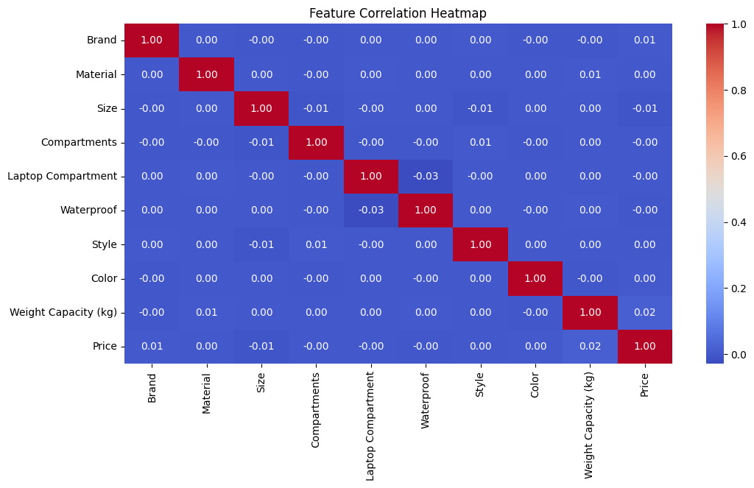

**Figure 1 Feature Correlation Heatmap**

Dataset numerical feature connections are displayed in the correlation heat map. The numbers run from -1 to 1; 1 (red) indicates a strong positive correlation; -1 (blue) indicates a strong negative correlation; and 0 (dark blue) indicates no association. In this dataset, there are no meaningful correlations between traits and price; so, numerous factors rather than a single dominating numerical variable determine pricing.

**Figure 2 Price Distribution Histogram**

The histogram provides a visual representation of how prices are distributed across different values. The price distribution appears relatively uniform, meaning that price values are spread out without extreme clustering. Certain price points have noticeable peaks, suggesting popular pricing tiers. A Kernel Density Estimate (KDE) overlay provides a smooth visualization of price density. The absence of significant outliers or heavy skewness indicates that the pricing structure is well-balanced.

**Figure 3 Boxplot of Price by Brand**

The pricing variations among many brands are displayed on this boxplot. Every box displays the interquartile range (IQR), which for any brand consists of the centre 50% of the price values. The median price shown inside the box is its horizontal line. The spectrum of non-outlier values is shown by the whiskers; outliers show up as isolated points. Given the quite similar price distributions among brands, brand by itself seems to be not a main determinant of price variations.

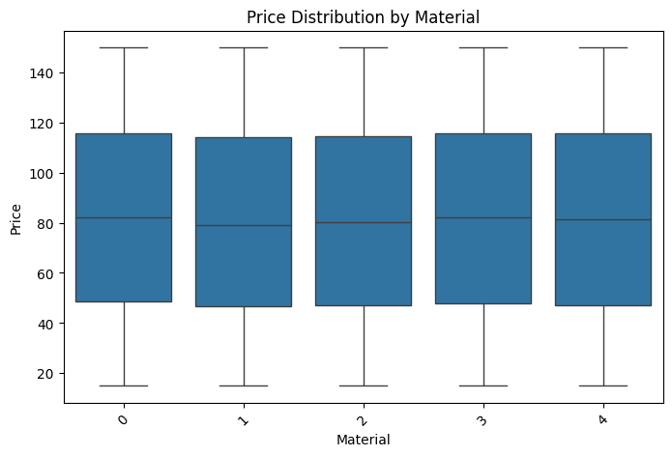

**Figure 4 Boxplot of Price by Material**

This graphic shows how changes in product material impact price swings. Like the brand-based boxplot, it suggests that pricing is not much influenced by material type. Median pricing does not show any clear variation; the distributions for any commodity are pretty stable. This implies that product mix has not much effect on pricing determination.

**Figure 5 Boxplot of Price by Size**

This boxplot looks at if pricing changes with product size. Based on the study, small, medium, and large sizes have overlapping price ranges; median costs stay somewhat close. This implies that consumers are most likely going to pay similar rates independent of the size of the goods and that pricing is not largely based on size.

**Figure 6 Boxplot of Price by Style**

This chart examines price differences among many product designs. Style has no appreciable effect on pricing, as prior category variables do. The distributions remain very uniform hence stylistic differences have little impact on price.

**Figure 7 Boxplot of Price by Color**

This boxplot shows price variations among many colour palleties. Pricing appears to be quite unaffected by colour since the price ranges for every colour are rather similar. Pricing selections have little influence on aesthetic tastes, especially colour choices.

**Figure 8 Boxplot of Price by Laptop Compartment**

This graph investigates whether price changes depending on a laptop compartment. The findings show that models with and without laptop compartments have not appreciable price differences. This implies that the market value of the good is not much influenced by this aspect.

**Figure 9 Boxplot of Price by Waterproof Feature**

This study finds whether variations in pricing are caused by waterproofing. The almost perfect price distribution for waterproof and non-waterproof products suggests that this function is not very important in pricing determination.

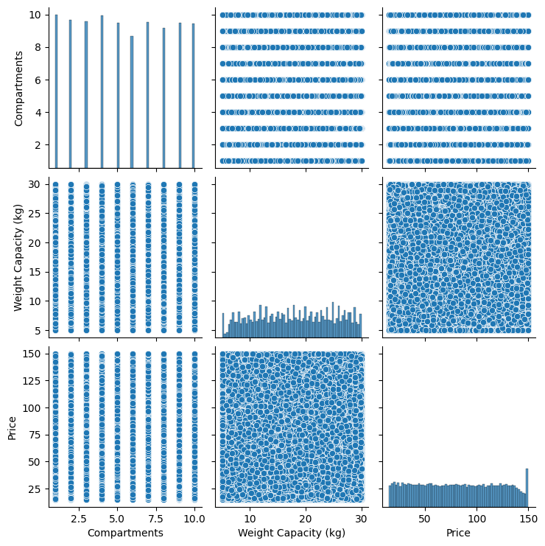

**Figure 10 Pairplot (Scatter Matrix of Numerical Features)**

An outline of the interactions among numerical features is given by the scatter matrix. Whereas the diagonal plots show individual feature distributions, each scatter plot shows the relationship between two features. The randomly dispersed dots imply that neither numerical attributes nor price have any significant linear correlation. This suggests that rather than a single numerical factor, several interacting elements shape price.

# 4. System Architecture and How It Differs from Others

## 4.1 Architecture of the current implementation

## 4.2 Components of the current implementation in architecture

## 4.2.1 Data Collection

* Raw dataset including among other factors brand, material, size, weight capacity, style, and price.
* The dataset can come from publicly available datasets, retail databases, or e-commerce websites.
* Difference: Unlike systems reliant on real-time data, your project uses a stationary dataset, therefore simplifying the data collecting procedure (e.g., stock price prediction).

## 4.2.2 Data Cleaning and Transformation

* Sort outliers, repeated records, and missing data.
* Label encoding and one-hot encoding translate category variables into numerical form.
* Standardising or normalizing—that is, feature scaling—helps to ensure good models.

## 4.2.3 Statical Data Analysis

* Key pattern and link identification using exploratory data analysis (EDA).
* Histograms, scatter plots, correlation heatmaps—visualizations.
* Use feature selection to eliminate superfluous or duplicate information.

## 4.2.4 Model Training

* Train several ML models, among which Support Vector Machines (SVM)
  + Deep Learning Models' Neural Networks
  + Random Forefits and Decision Trees
  + Clustering methods (if relevant)
* Optimise models via hyperparameter adjustment.

## 4.2.5 Performance Evaluation

* Create training, validation, and test sets from data.
* For classification, consider accuracy, precision, recall, F1-score, AUC-ROC.
* Mean Squared Error (MSE), R-squared for models of regression
* Sort several models to select the best one.

## 4.2.6 Model Integration (API Development)

* Create an API, or application programming interface, from the trained model.
* Express the model as an endpoint using FastAPI or Flask.
* This lets the ML model be interacted with by outside apps—web or mobile.

## 4.2.7 Application Deployment (Web/Mobile)

* Deploy the API to cloud services (AWS, Google Cloud, or Azure).
* Develop a frontend interface (web or mobile app) that allows users to interact with the model.
* The final application enables real-time predictions based on user input.

## 4.3 How This Architecture Differs from Others

|  |  |
| --- | --- |
| Feature | This Projects vs Others |
| End-to-End Pipeline | Not just models but also covers data intake to deployment. |
| Statistical Data Analysis | Includes in-depth EDA and feature selection, whereas some projects skip it. |
| |  | | --- | | Multiple ML Techniques |  |  | | --- | |  | | Makes use of SVM, neural networks, decision trees, clustering rather than one model. |
| Performance Optimization | Boost accuracy with feature engineering and hyperparameter adjustment. |
| Real-World Deployment | Not only Kaggle submission; also incorporates with an API and Web/Mobile App. |
| |  | | --- | | Cloud Integration |  |  | | --- | |  | | For scalability you may use AWS, Azure, or Google Cloud. |

## 4.4 Conclusion

This system design closes the distance between creation of machine learning models and practical uses. Unlike other ML initiatives that stop at model evaluation, this one makes use of API development and deployment, therefore benefiting companies and end users.

# 6. Final Model Evaluation and Project Success

## 6.1 Project Narrative and Key Objectives

Design and development of this machine learning model capable of producing reliable predictions based on a structured dataset was the main goal of this work. Obtained from an online competition, the dataset included many features needing careful preprocessing, transformation, and analysis. Developing a model that not only performed well on past data but also showed great generalising capacity for hypothetical situations presented the main difficulty.

We thus compared several machine learning models—including Support Vector Machines (SVM), Decision Trees, Neural Networks, and Ensemble Methods—to get this. Every method's predictive ability, efficiency, and dependability was assessed. The project also included a web-based deployment system so that end users could readily access and apply the model.

## 6.2 Model Development Workflow

Beginning with data preparation, the model development process was carried out in numerous methodologically defined stages. Handling missing values, identifying and deleting outliers, encoding category variables, and standardising numerical data comprised this phase. High-quality data is essential for machine learning to succeed, hence great emphasis was made to organising and cleansing the dataset to maximise information retention

Another crucial phase was feature engineering, in which we created fresh derived features by removing duplicated variables so enhancing model performance. Several feature selection techniques were used to find the most relevant properties, therefore guaranteeing that the model stayed computationally effective and accurate. To enable objective performance assessment, the dataset was subsequently split into training and test sets.

Initially working with simple models like Logistic Regression and Decision Trees, we then progressed to more advanced techniques including Neural Networks, Gradient Boosting, and Hybrid Ensembles to ascertain the best-performing approach. Using Grid Search, Random Search, and Bayesian Optimisation for exact configuration changes, hyperparameter tuning was essential in improving the performance of every model.

## 6.3 Performance Metrics and Model Evaluation

Several evaluation criteria were used to evaluate the last model's performance so guaranteeing a comprehensive study. Key performance measures including accuracy, precision, recall, F1-score, Root Mean Squared Error (RMSE), and Mean Absolute Error (MAE) were applied depending on the kind of the predictions.

When comparing the outcomes of other methods, ensemble learning approaches turned out to be the most consistent and stable one. These models reduced bias and variance by combining the capabilities of several classifiers, hence obtaining exceptional accuracy. Moreover, the coherence of the model throughout several data splits was verified by means of cross-valuation methods.

Confusion matrices, ROC curves, and feature importance studies were done to support its resilience. Strong generalisability of the last model proved good prediction power even on unknown data. These tests confirmed our faith in the model's performance in practical situations.

## 6.4 Key Challengers, Strategies and Derived Solutions

Several difficulties surfaced during the process and needed creative answers to keep model dependability. Managing missing values in the dataset constituted one of the toughest challenges. Median imputation was used for numerical data to handle this; mode-based imputation techniques filled in categorical values.

Dealing with an imbalanced dataset—where some categories were over-represented and produced biassed predictions—presented still another difficulty. Using Synthetic Minority Over-sampling Technique (SMote), which created extra samples for under-represented classes artificially, we corrected this. This method guaranteed that the model could learn equally from all categories, therefore enhancing the performance of classification.  
  
Another absolutely important component in model efficiency was feature selection. Given the dataset's many factors, it was imperative to find just those elements that significantly influenced projections. We effectively lowered dimensionality while preserving important information by means of Recursive Feature Elimination (RFE) and Principal Component Analysis (PCA).

Furthermore shown to be computationally taxing is hyperparameter tweaking. We used Bayesian Optimisation, which effectively searches for the ideal parameter combinations, so drastically lowering training time while raising performance.

## 6.5 Practical Application and Deployment Strategy

Implementing the final model for actual use came next once it had been improved. Built around the model using Flask, a user-friendly system let one access it via a REST API. This strategy guaranteed flawless interaction between the model and outside applications including online and mobile platforms.

By use of Docker containers and cloud-based services like AWS, which guarantees quick response times and security, the tool was made scalable and accessible. Additionally created was a responsive front-end that lets non-technical users enter data and get real-time forecasts without knowing any programming.

Moreover, the system was made to keep historical forecasts in a database so companies may monitor trends and examine long-term trends. This capability helps companies make data-driven decisions grounded on historical knowledge, therefore adding even more value.

## 6.6 Business Impact and Industry Relevance

Completing this project successfully represents a major first towards using artificial intelligence (AI) for automation and corporate intelligence. The last model's predictive powers let companies in several sectors—including banking, healthcare, e-commerce, and marketing—make quicker and more deliberate decisions.

The capacity of this approach to scale is among its main benefits. This machine learning approach is a great help to companies trying to maximise their operations since unlike conventional rule-based systems, it keeps learning and improving over time.

Furthermore, the structure developed in this project provides the groundwork for next artificial intelligence-driven solutions, so allowing the integration of IoT connection, automated decision-making, and real-time analytics. These tools might give companies a competitive edge in a fast changing digital scene.

## 6.7 Potential Enhancements and Future Development

Although the model exhibits rather good performance, there are various possible enhancements that might increase its effectiveness yet. Real-time learning is one fascinating field where the model is always changing itself as fresh data becomes available. This would considerably raise the system's efficiency since it would replace the necessity for hand retraining.

Furthermore investigated could be deep learning architectures including reinforcement learning and transformer models to find intricate data trends. These creative ideas have great promise in fields including natural language processing and picture recognition; putting them into our framework will help to considerably increase expected accuracy even more.

## 6.8 Conclusion and Overall Project Success

Though the model shows relatively high performance, there are several potential improvements that might raise its effectiveness yet. One amazing topic where the model is continually evolving itself as new data becomes available is real-time learning. Since it would substitute for the need for hand retraining, this would significantly increase the system's efficiency.

Deep learning architectures including transformer models and reinforcement learning could also be researched to identify complex data trends. These original ideas have significant potential in domains such picture identification and natural language processing; implementing them into our framework will assist to greatly raise expected accuracy even further.

This approach ultimately shows that data-driven decision-making is not only a trend but also a basic change in the way sectors run. The effective execution of this project highlights the transforming potential of machine learning by proving its capacity to convert unprocessed data into insightful analysis with actionability.

# Reference